Reg#9011

Restaurant Management App

Software Requirements Specification (SRS)

1. Introduction

1.1 Purpose
The Restaurant Management App is a mobile application created to improve the restaurant experience for both customers and restaurant staff. The purpose of this system is to make restaurant operations easier by digitizing common tasks such as menu browsing, food ordering, reservation handling, and order management.
This app will help customers place orders more easily and allow restaurant management to organize daily operations in a more efficient way.

1.2 Scope
The Restaurant Management App is designed to support the basic needs of a modern restaurant. It allows customers to browse the menu, place orders, and reserve tables, while also giving the restaurant staff and admin the ability to manage food items, orders, and customer requests.

Main Features Included
- Account creation and login
- Menu display
- Search and category filter
- Add to cart and checkout
- Order tracking
- Reservation system
- Admin dashboard
- Staff order handling
- Sales and report viewing

Features Not Included in MVP
The following are not part of the first version:
- Live customer chat
- Real-time GPS delivery tracking
- Loyalty rewards
- Support for multiple restaurant branches

1.3 Key Terms
Term | Meaning
Customer | A user who browses food items and places orders
Admin | A user who manages the system
Staff | Restaurant employees who handle orders and reservations
Order | A food request made by a customer
Reservation | A table booking made in advance
MVP | Minimum Viable Product
CRUD | Create, Read, Update, Delete
UML | Unified Modeling Language

2. System Overview

2.1 General Description
The Restaurant Management App is a restaurant support system that helps in managing food ordering and restaurant tasks digitally. It acts as a bridge between customers and restaurant staff by making the process smoother, faster, and more organized.
This system can reduce manual work and improve customer satisfaction by making restaurant services more accessible through a mobile device.

2.2 User Roles
The application will include three types of users:
User Role | Responsibilities
Customer | Browse menu, search food, place orders, reserve tables, manage profile, and view order history
Admin | Manage menu items, staff, orders, and reports
Staff | Handle incoming orders, update order status, and manage reservations

2.3 User Stories
- As a customer, I want to browse food items so I can quickly choose what I want to eat.
- As a customer, I want to place an order easily so I can save time.
- As a staff member, I want to update the order progress so customers know their order status.
- As an admin, I want to manage menu items and reports so the restaurant can run smoothly.

3. Functional Requirements
The Restaurant Management App should provide the following functionalities:
- FR1: The system shall allow users to register using an email and password.
- FR2: The system shall allow users to log in and log out securely.
- FR3: The system shall allow customers to create and edit their profile.
- FR4: The system shall display the restaurant menu with food and drink items.
- FR5: The system shall allow customers to search for menu items by name or category.
- FR6: The system shall allow customers to add menu items to a cart.
- FR7: The system shall allow customers to place orders from the cart.
- FR8: The system shall allow customers to view order status after placing an order.
- FR9: The system shall allow customers to view their previous order history.
- FR10: The system shall allow customers to reserve a table.
- FR11: The system shall allow customers to cancel a reservation or order before confirmation.
- FR12: The system shall allow admins to add, update, and delete menu items.
- FR13: The system shall allow admins to monitor restaurant orders.
- FR14: The system shall allow admins to manage staff records.
- FR15: The system shall allow admins to view restaurant sales and reports.
- FR16: The system shall allow staff to update order status such as “Preparing”, “Ready”, or “Delivered”.
- FR17: The system shall store customer, order, reservation, and menu data in a database.

4. Non-Functional Requirements

4.1 Usability
- The app should have a simple and user-friendly interface.
- Customers should be able to place an order in a few steps.
- Navigation should remain clear and consistent across all screens.

4.2 Performance
- The application should load screens quickly.
- Menu items and orders should appear without long delays.
- The app should perform smoothly during regular use.

4.3 Security
- User passwords must be encrypted before being stored.
- Data transfer between the mobile app and server should be secure.
- User information should be protected from unauthorized access.

4.4 Reliability
- The system should work properly without crashing often.
- Order and user data should remain safe and available.
- The app should provide stable performance during normal restaurant usage.

5. Database Requirements
The Restaurant Management App will use a database such as MongoDB to save and manage all important system data.

Main Collections / Tables
Collection | Fields | Purpose
Users | _id, name, email, passwordHash, role, phone | Stores customer, admin, and staff information
MenuItems | _id, name, description, category, price, availability | Stores food and drink items
Orders | _id, customerId, items[], totalAmount, status, createdAt | Stores customer orders
Reservations | _id, customerId, date, time, tableNo, status | Stores reservation records
Payments | _id, orderId, amount, method, paymentStatus | Stores payment details

7. MVP Frontend Overview (React Native)
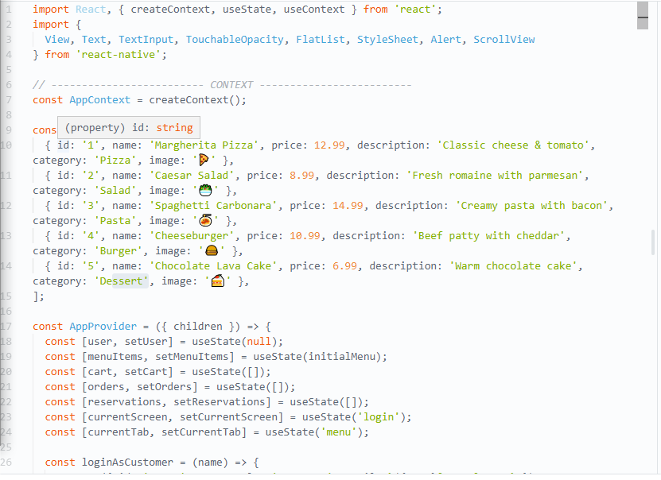
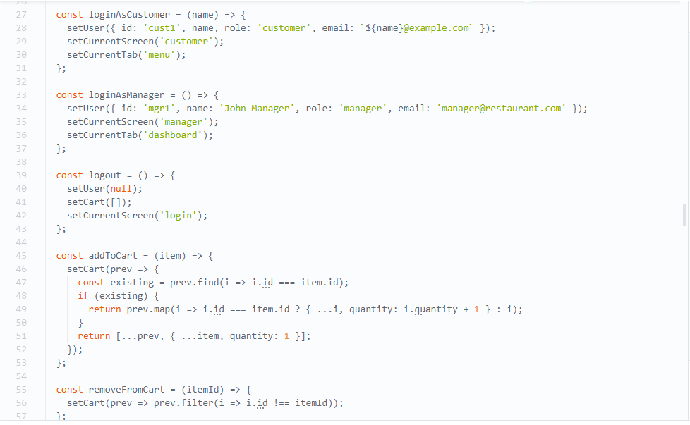
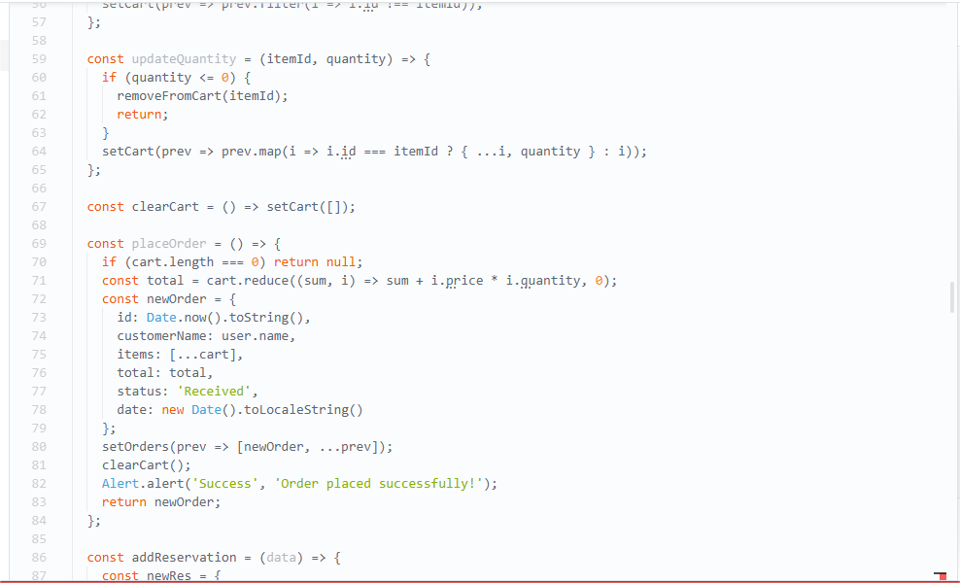

7.1 Login / Signup Screen
Purpose:
Allows users to create an account or log into the system.
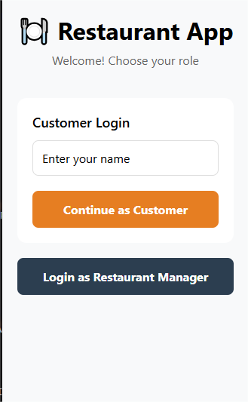

7.2 Home / Menu Screen
Purpose:
Displays the available food and drink items in a scroll able list.

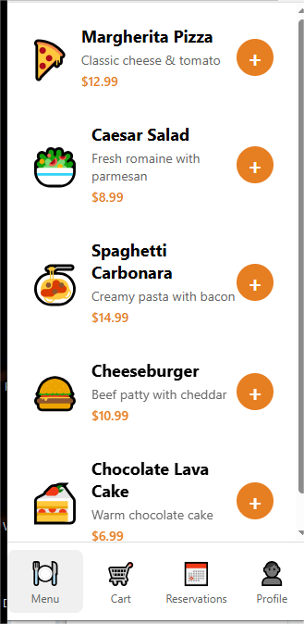

7.3 Cart / Checkout Screen
Purpose:
Shows selected food items and allows the customer to place the final order.
Functionality:
When the customer taps “Place Order”, the order is saved and the user is redirected to the order tracking page.
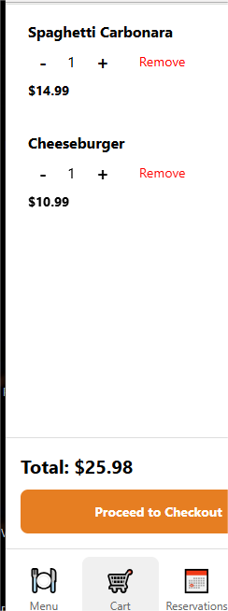

7.4 Reservation Screen
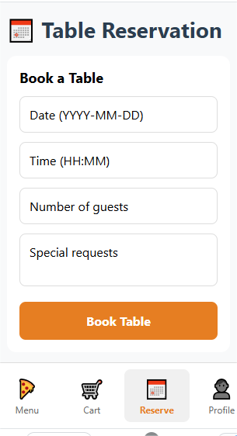

7.5 Admin Dashboard
Purpose:
Allows the admin to manage the restaurant’s daily operations.
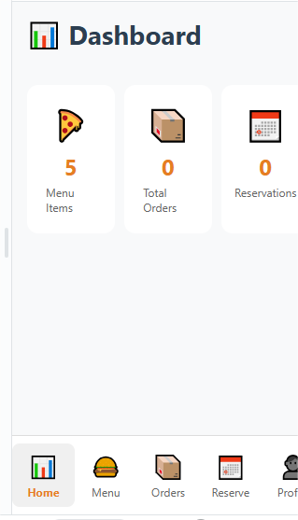
Main Features:
- View total orders
- Manage menu
- Check sales
- Manage staff

9. Conclusion
The Restaurant Management App is designed to make restaurant operations more organized and customer-friendly. It helps customers place orders and reserve tables easily, while also supporting staff and admin in managing food items, customer requests, and restaurant performance. This SRS provides the key system requirements needed to build the application.

